Angular interview questions notes

25 June 2022

20:19

* 1. Component is the one basically it acts as an mediator between the view and the model , in order for binding our codes we use components , in order for binding the css.

* 1. Decorator :- Decorator says what kind of angular classes is it .., what exactly is the type of the class..

* 1. Npm install @Angular/CLI

* 1. Npm stands for node package manager

* 1. In order for creating the module we needs to use @ng module decorator ,

While that comes to the instance of creating the component we needs to use @Component Decorator.

* 1. Sometimes even we term the decorators to be as annotations /Meta data. -> don’t get surprised answer is same as that of the Decorator.

* 1. Templates : are nothing but the Html view in the angular.

8) what is Data binding in angular :- it's basically how the view and the component communicate with each other.

* 1. The expression binding {{ }} is also called as interpolation binding …the data flows from controller to the view and in order for mixing the data in the html we are using this type of binding.

* 1. [(ngmodel)] - this type of binding is called as an property Binding []:- the data flows from controller to the view it will get attached to some user input such as text boxes …

* 1. Event Binding :- whenever if a user clicks on particular button , some event , some action takes place …(click) - a round brackets we use.
  2. Two way binding means [()] - both property and event bindings are encapsulated ….



* 1. Explain the important pillars which comprises the angular ?? :-

The template is nothing but the html view. Modules groups the components, directives help you to change the Dom behaviour. Services is nothing but the common logic , which we inject across all the Projects.

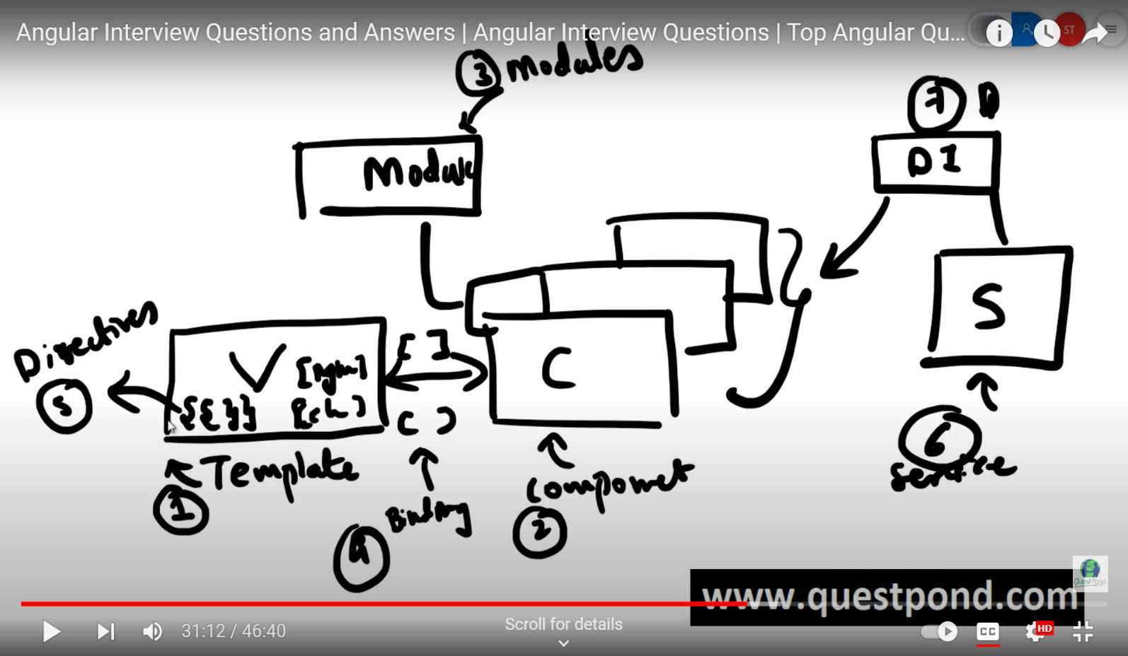

7 points to remember

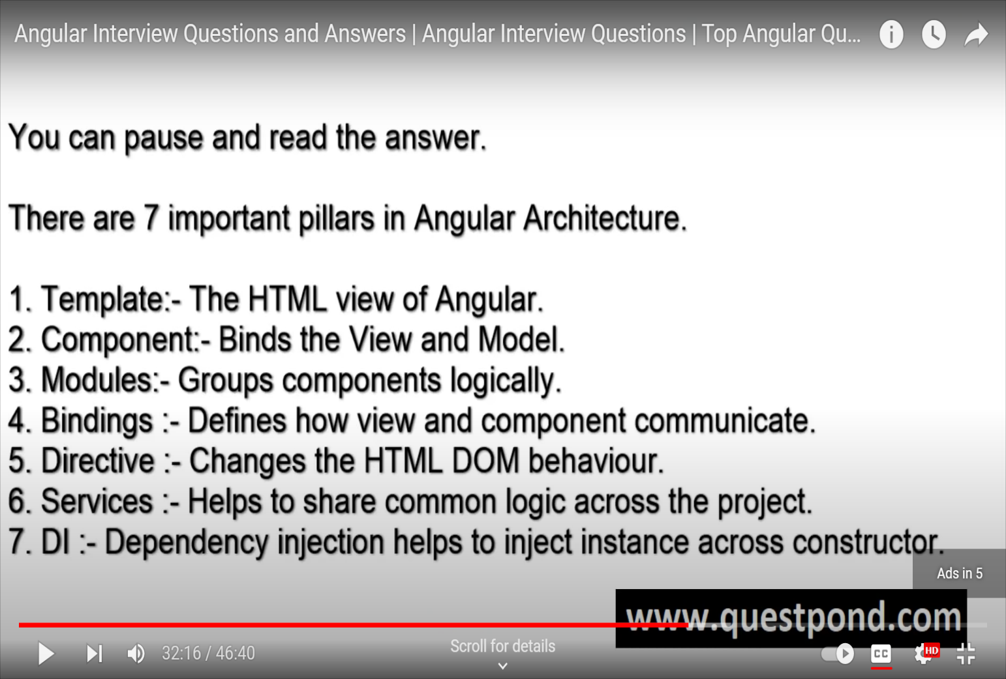

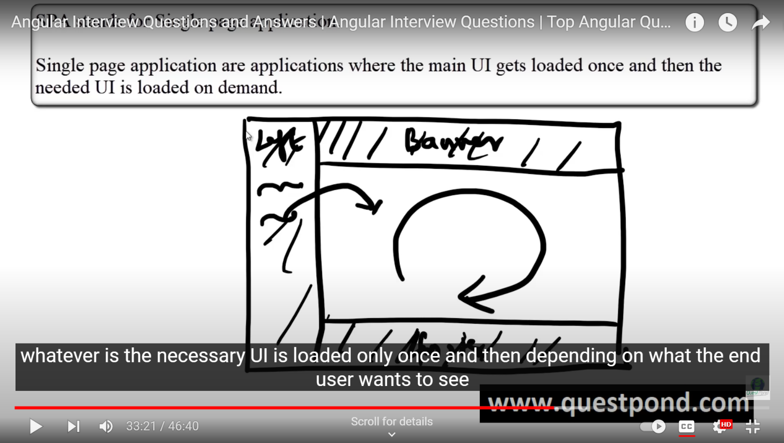

The router outlet is the place where our page will be loaded..

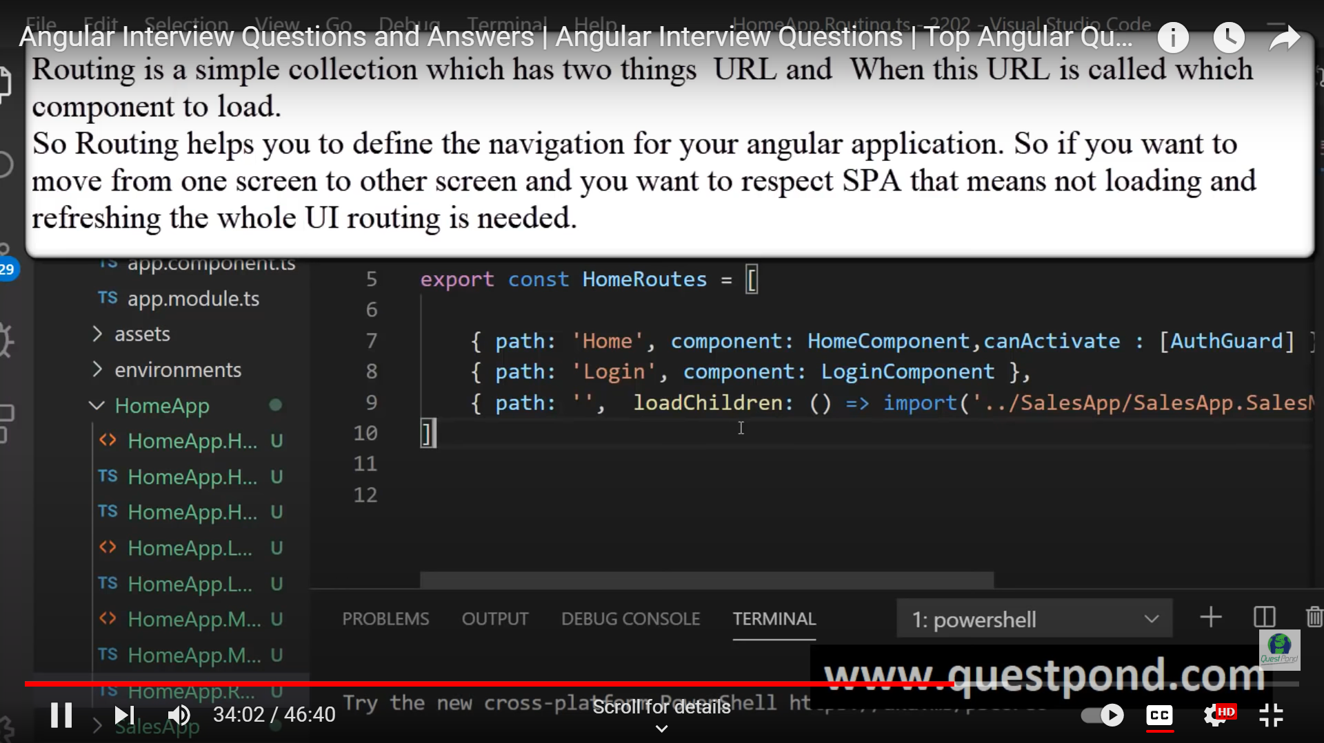

* 1. What is lazy loading in angular ???

The lazy loading means on demand loading or loading what is essential or necessary , we needs to do divide the project in separate , separate modules , without which the lazy loading is not possible ….

21) What are services ??

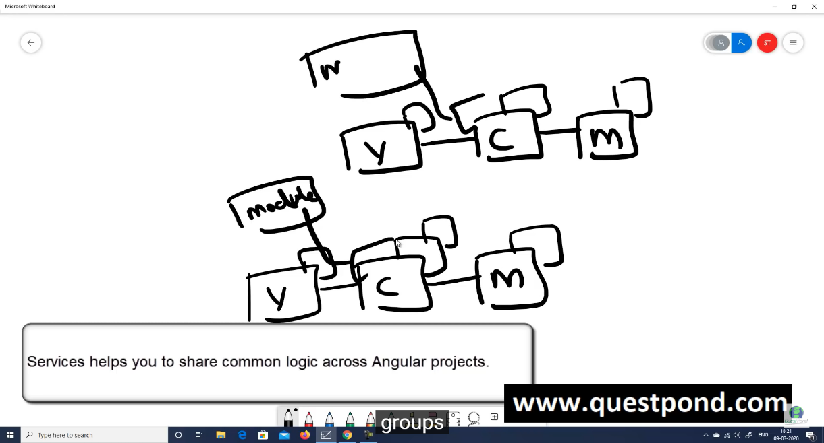

22)what is dependency injection?? :- for implementing the di we needs to use the providers in the ng module

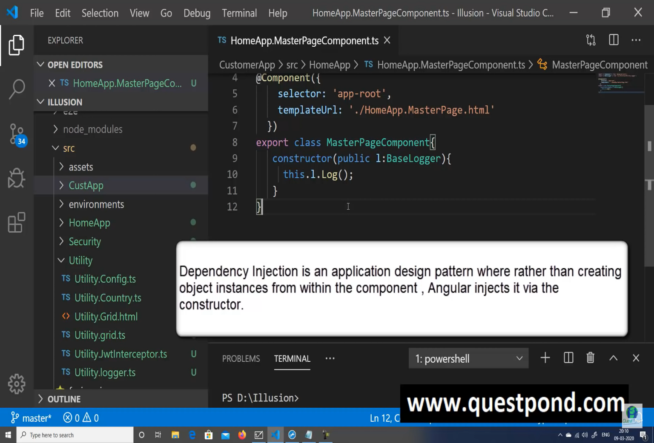

* 1. The benefit of using Dependency injection is decoupling:- if we change at one place , the changes needs to get Reflected(across all the projects) in the multiple places.

* 1. Differentiate between ng serve and ng Build

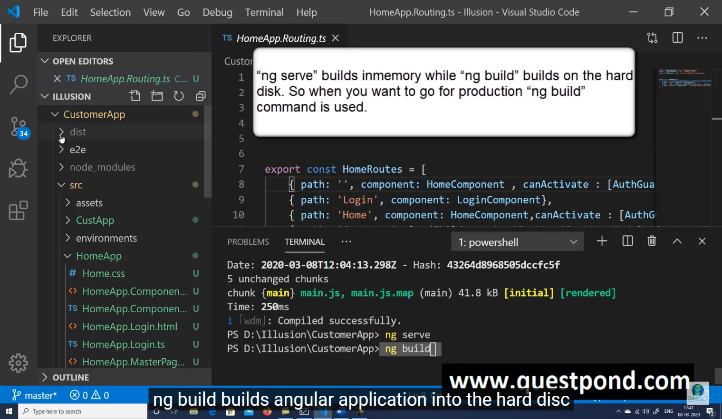

25)

